

Department of Computer Science Course Code: CNS 303
Course Title: Cloud Computing Fundamentals

SPRING 2026

Lab 02
Objective:
Implementation of distributed database server.

Student Information

Student Name
Student ID
Date
Assessment
Marks Obtained
Remarks
Signature

Distributed Database System
A Distributed Database System (DDBS) is a collection of multiple databases spread across different physical locations, connected via a network. Unlike a centralized system, where all data is stored in one place, a distributed system manages data across various sites while making it appear as a single database to users. It improves data availability, reliability, and performance by enabling local access, parallel processing, and fault tolerance.
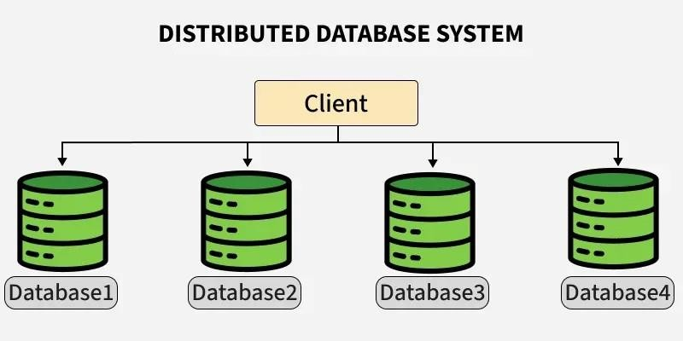
Distributed Database

Types

Some of the type of distributed database system are:

Homogeneous Database:
In a homogeneous database, all different sites store database identically. The operating system, database management system, and the data structures used all are the same at all sites. Hence, they're easy to manage.

Features:
Unified query language and interface.
Low integration complexity.
Efficient synchronization.

Example: A bank with branches in different cities uses Oracle DB at every location. All databases have the same structure and are synchronized regularly.

Heterogeneous Database
In a heterogeneous distributed database, different sites may use different DBMSs, schemas, or data models, making query processing and transactions difficult. Some sites may not even be aware of others, so translation mechanisms are needed for communication.

Features:
Supports interoperability between diverse systems.
Complex query optimization and transaction management.
Useful in mergers or collaborations between organizations.

Example: A logistics company uses MySQL for inventory, MongoDB for vehicle tracking, and PostgreSQL for billing. Integration middleware allows unified querying across these platforms.

Client-Server Distributed Database System
In this model, the server stores and manages the database, while clients send queries over the network. It offers centralized control with distributed access, making it ideal for enterprise systems and web applications. Clients can be lightweight while the server handles heavy processing.
Example: Web application interacting with a central PostgreSQL server.

Features:
- Simplifies resource management.
- Central servers can be optimized for performance.
- Easily scalable with more clients.

Example: An e-commerce website where the frontend (client) is hosted separately and interacts with a central PostgreSQL server to manage orders, users, and inventory.

Peer-to-Peer Distributed Database System
Here, all nodes are equal, with no fixed client or server roles. Each node can store data and also process queries, leading to decentralized control. It supports fault tolerance and high availability. Example: Blockchain networks like Ethereum, where each node maintains a part of the distributed ledger.

Features:
No single point of failure.
Useful in decentralized and distributed apps.
High availability and data redundancy.
Example: Block chain-based databases like Ethereum or BitTorrent-based systems, where each peer maintains part of the ledger and participates equally in transactions.

Cloud-Based Distributed Database System
These systems are deployed on cloud platforms and span multiple geographic regions for scalability and reliability. They abstract infrastructure details and are offered as DBaaS, making them ideal for dynamic workloads. Example: Google Cloud Spanner and Amazon DynamoDB used for global applications.

Features:
  - Automatic scaling and replication.
  - Pay-as-you-use pricing.
  - Global availability and disaster recovery.
Example:
    - Google Cloud Spanner: Global-scale relational database.
    - Amazon DynamoDB: Key-value and document database with high performance.
    - Azure Cosmos DB: Multi-model, globally distributed DBMS.

key components and challenges of a Distributed Database
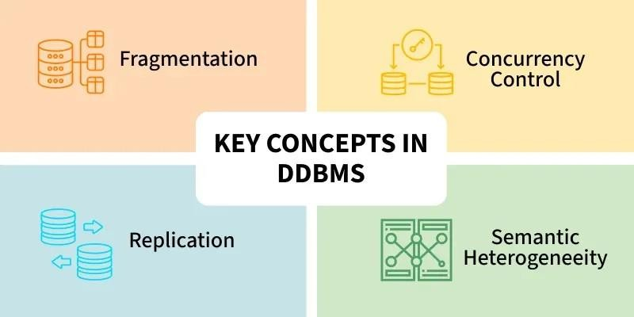

Replication
In replication, copies of the same data are stored at two or more sites. If every site has the full database, it's called full replication. This improves data availability and allows faster, parallel query processing. However, updates must be made at all sites, or data may become inconsistent. It also adds overhead and makes concurrency control more complex.

Fragmentation
In this approach, the relations are fragmented (i.e., they're divided into smaller parts) and each of the fragments is stored in different sites where they're required. It must be made sure that the fragments are such that they can be used to reconstruct the original relation (i.e, there isn't any loss of data).

Fragmentation is advantageous as it doesn't create copies of data, consistency is not a problem. Fragmentation of relations can be done in two ways:
  - Horizontal fragmentation - Splitting by rows
The relation is fragmented into groups of tuples so that each tuple is assigned to at least one fragment.
  - Vertical fragmentation - Splitting by columns
The schema of the relation is divided into smaller schemas. Each fragment must contain a common candidate key so as to ensure a lossless join.
In certain cases, an approach that is hybrid of fragmentation and replication is used.

Concurrency Control
Concurrency control ensures data remains accurate when multiple transactions run at the same time. Without it, issues like lost updates or dirty reads can occur. Its goal is to make parallel transactions behave as if run one by one. Common methods include locking, timestamps, and optimistic concurrency.

Semantic Heterogeneity
Semantic heterogeneity happens when different databases use the same data labels but with different meanings, formats, or units. For example, one system may store salary in dollars, another in rupees. This can cause confusion during data integration, so resolving it is important for accurate results.

Advantages of Distributed Database System :
- There is fast data processing as several sites participate in request processing.
- Reliability and availability of this system is high.
- It possesses reduced operating cost.
- It is easier to expand the system by adding more sites.
- It has improved sharing ability and local autonomy.

Disadvantages of Distributed Database System :
- The system becomes complex to manage and control.
- The security issues must be carefully managed.
- The system requires deadlock handling during the transaction processing otherwise
- The entire system may be in inconsistent state.
- There is need of some standardization for processing of distributed database system.

Implementations

Linked Servers (MS SQL SERVER)

Let’s say you have a Main Server and two other servers:

  - ServerA
  - ServerB

We’ll create linked servers from the main server to both ServerA and ServerB.

Step 1: Open SQL Server Management Studio (SSMS)
- Connect to your main SQL Server (the one that will fetch data from others).
- In Object Explorer, expand:
- Server Objects → Linked Servers → New Linked Server

Step 2: Configure the Linked Server
In the New Linked Server dialog:
  - Linked server: A name you’ll use to reference the remote server (e.g., ServerA_Link)
  - Server type: Choose SQL Server
  - Server name: Enter the remote server name or IP (e.g., ServerA\MSSQLSERVER or 192.168.1.20)

Example:

Field | Value
Linked server | ServerA_Link
Server type | SQL Server
Server name | ServerA

Step 3: Set Security Settings
  - Go to Security tab.
  - Choose one of the following options:
    - Be made using the login’s current security context – Uses the same login credentials as the local server.
    - Be made using this security context – Enter a specific username/password from the remote server.

Example:

  - Remote login: sa
  - Password: your_password

Step 4: Test the Connection
After saving:

  - Expand Linked Servers → You should see ServerA_Link
  - Right-click and choose Test Connection

If successful — you can now query remote data. Step 5: Query Data from the Linked Server Now you can fetch data like this:
-- Query table from ServerA
SELECT * FROM [ServerA_Link].[DatabaseName].[Schema].[TableName];

-- Query table from ServerB
SELECT * FROM [ServerB_Link].[DatabaseName].[Schema].[TableName]; Example:
SELECT * FROM [ServerA_Link].[SalesDB].[dbo].[Customers]; SELECT * FROM [ServerB_Link].[FinanceDB].[dbo].[Transactions]; Step 6: Combine Data from Multiple Servers
You can even JOIN data from different linked servers:

SELECT
A.CustomerID, A.CustomerName, B.TotalAmount
FROM [ServerA_Link].[SalesDB].[dbo].[Customers] A JOIN [ServerB_Link].[FinanceDB].[dbo].[Transactions] B
ON A.CustomerID = B.CustomerID;

- Ensure TCP/IP is enabled on all SQL Servers (via SQL Server Configuration Manager).
- Allow remote connections in SQL Server properties.
- Make sure the SQL Server Browser service is running if you use named instances.
- Use proper firewall rules to allow communication between servers.

REFERENCE: Document is available with this manual to show the step to implement the link server.

- Replication in MS SQL Server
Replication is used to copy and distribute data from one database to another and synchronize it to maintain consistency.

Before we start, remember the main roles in replication:

Role | Description
Publisher | The source server/database where the data originates.
Distributor | Manages replication by storing metadata and transactions. Can be on the same server  as the publisher or a separate one.
Subscriber | The destination server/database that receives the replicated data.

Step 1: Prepare All Servers
Before replication:

  - Make sure all SQL Servers (Publisher, Distributor, Subscriber) are installed and network- accessible.
  - Enable SQL Server Agent service (needed for replication jobs).
  - Ensure proper logins exist on all servers.

Step 2: Configure the Distributor
- Open SQL Server Management Studio (SSMS) and connect to the Publisher server.
- In Object Explorer, expand the server → Expand Replication → Right-click Local Publications → Click Configure Distribution…
- In the wizard:
  - Choose “Server will act as its own Distributor” (or choose a remote distributor if using a separate one).
  - Specify the snapshot folder location (shared folder accessible to all involved servers).
  - Complete the wizard.

This creates the distribution database and configures the Distributor.

Step 3: Configure the Publisher (Create a Publication)
- In Object Explorer, expand Replication → Right-click Local Publications → Click New Publication…
- Select the database you want to replicate.
- Choose the Replication type:
  - Snapshot replication – sends the entire dataset at intervals (best for small/static data).
  - Transactional replication – sends changes almost instantly (best for high-volume, frequently updated data).
  - Merge replication – allows changes on both publisher and subscriber, then merges them.
- Select the tables, views, or stored procedures you want to replicate.
- Configure a Snapshot Agent schedule (how often the snapshot runs).
- Create a Publication name (e.g., Sales_Replication).
- Finish the wizard.

Now the Publisher is ready.

Step 4: Configure the Subscriber (Create a Subscription)
- On the Publisher server, expand Replication → Local Publications.
- Right-click your new publication → New Subscriptions…
- In the wizard:
  - Choose the publication created earlier.
  - Choose the distribution agent location:
    - Push – Publisher pushes data to Subscriber (most common).
    - Pull – Subscriber pulls data from Publisher.
- Choose the Subscriber server and database (create a new database if needed).
- Set synchronization schedule (e.g., continuous or scheduled).
- Complete the wizard.

✅ The subscriber is now configured and will receive data.

Step 5: Start and Monitor the Replication
- Go to Replication → Local Publications → Right-click → View Snapshot Agent Status
- Make sure the snapshot runs and completes.
- You can view replication status under:
  - Replication Monitor (Right-click Replication → Launch Replication Monitor)
  - Check latency, errors, and sync details.

Step 6: Test the Replication
- Insert or update data in the Publisher database.
- Verify the same changes appear in the Subscriber database.

REFERENCE: Document is available with this manual to show the step to implement the link server.
TASK:

- Install MS SQL SERVER 2019 Enterprise.
- Create Linked servers in between 3 nodes.
- Create Replication server which communicate from two servers with identical schemas.

